

**HR’s ESG Value Statement**

**Introduction**

[Provide context for your organization’s ESG commitment and highlight the broader impact on employees, stakeholders, and communities. This should guide HR’s commitment.]

|  |
| --- |
| **Example** At [Organization name], we recognize that our people fuel our success, and their empowerment drives our purpose. Aligning with Environmental, Social, and Governance (ESG) principles is not just a strategy—it’s a commitment to creating a workplace built on trust, equity, and responsibility.By embedding ESG into everything we do, we aim to strengthen our culture, foster long-term resilience, and contribute positively to the communities we serve. |

**Why HR is committed to ESG**

[Explain the purpose of your HR team's ESG commitment. Focus on the impact and benefits for employees, the organization, and society.]

|  |
| --- |
| **Example**  Our HR function is deeply committed to fostering sustainable, ethical, and human-centered workforce practices. We believe that prioritizing social responsibility and ethical decision-making not only enhances employee satisfaction but also shapes a resilient, fair, and inclusive workplace. By focusing on creating a thriving organizational environment, we play a key role in driving long-term positive impacts for our employees, stakeholders, and the wider community. |

**HR’s focus priorities**

[Outline the specific areas of focus that the HR function prioritizes in its ESG efforts. Be clear about the practices, processes and initiatives that HR undertakes.]

|  |
| --- |
| **Example**  We achieve our ESG goals through these HR practices:   * **Talent management:** Hiring, developing, and retaining talent in a way that supports long-term career opportunities while meeting business goals. * **Diversity, Equity, and Inclusion (DE&I) initiatives:** Building a workforce that reflects diverse perspectives, promotes equity, and ensures that all voices are heard. * **Employee wellbeing:** Investing in physical, emotional, and financial health through wellness programs, mental health resources, and support systems. * **Ethical governance:** Adhering to strict codes of conduct and transparent policies that align with legal and social accountability standards. |

[](https://www.aihr.com/business/)



**HR’s ESG Value Statement**

**How HR will achieve this**

[Detail the strategies, tools, and outcomes of these efforts with a focus on measurable and actionable results.]

|  |
| --- |
| **Example**  We bring our ESG principles to life through targeted strategies including:   * **Stakeholder engagement:** Collaborating with employees and leadership to ensure ESG goals align with organizational and societal values. * **Data-driven decisions:** Leveraging people analytics to track progress on diversity metrics, employee engagement, and retention rates. * **Risk mitigation:** Proactively addressing potential ESG-related risks, such as ethical compliance lapses or workplace inequities, through training and accountability programs. * **Long-term value creation:** Implementing programs that not only create immediate impact, such as leadership development, but also prepare us for a sustainable future, like transitioning to green office practices. |

**Closing statement**

[Reaffirm your HR department's dedication to ESG values in a concise and motivating way.]

|  |
| --- |
| **Example**  Our HR team is dedicated to building sustainable, inclusive, and ethical practices into the core of our organization. Together, we aim to create a workplace where everyone can succeed while making a positive impact on society, the environment, and our company’s future. |

**ESG value statement tracking**

[List which documents or policies the ESG statement has been included in to track and maintain when revisions are made.]

|  |  |
| --- | --- |
| **Document** | **Last update date** |
| [Careers website] | 12.02.2025 |
| [ESG company booklet] | 12.10.2024 |
|  |  |

[](https://www.aihr.com/business/)

[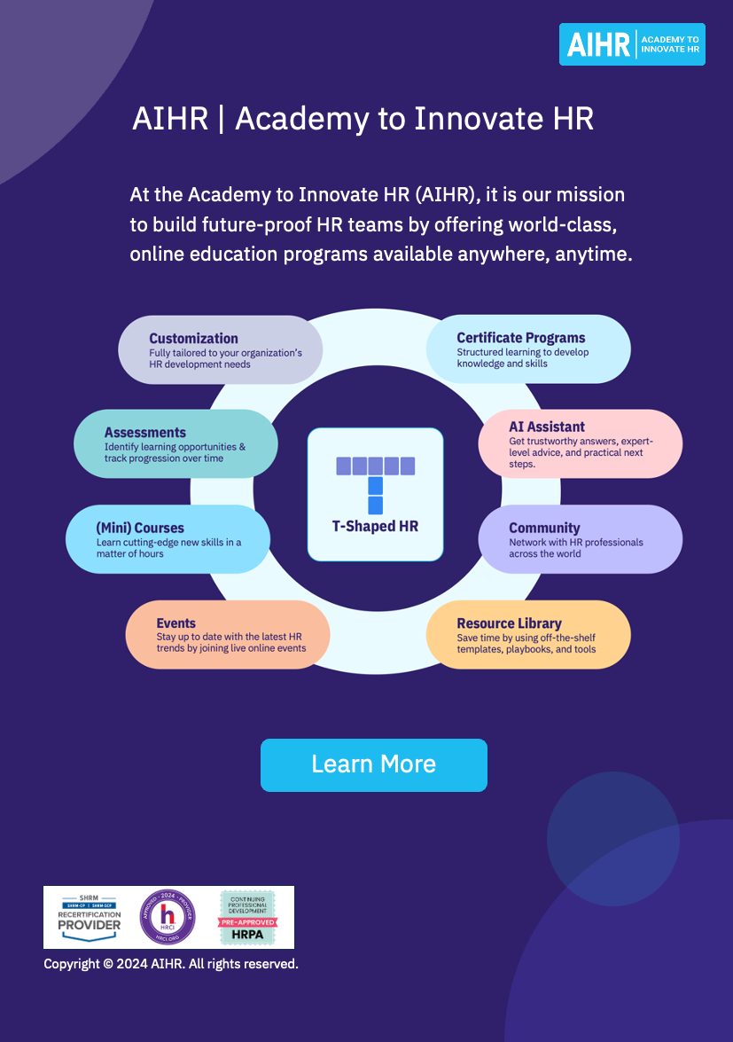](https://www.aihr.com/business/?utm_source=resource&utm_medium=resource&utm_campaign=templates&utm_content=templates)